**Week 3 Interview Questions**

What is the purpose of this software?

* Is it going to be used alongside a marking rubric?
* Is it going to have to incorporate all elements affecting a student’s mark?
* Does it need any security built into it?
* Who should be able to access it.
  + *Refer to GitInspector version.*
* How should the file be created? (i.e. do you want to be able to email within the app etc).

How do you want the final product delivered?

- Desktop application preferred.

- Software will create a word doc.

*Client recommends using a web application to ensure constant communication between the software and Google Drive.*

What are the key features that you would like access to?

* *Pie charts, timeline graphs, charts.*
* outputs
* Most important features
* What would you like from the github version?
* What would you like done differently from the github version?
* What constitutes a change? Changing font, fixing spelling error or changing line(s) in the document, amount of docs
* How would you like the timeline to operate?
  + *Weekly basis is favoured by the client.*
* 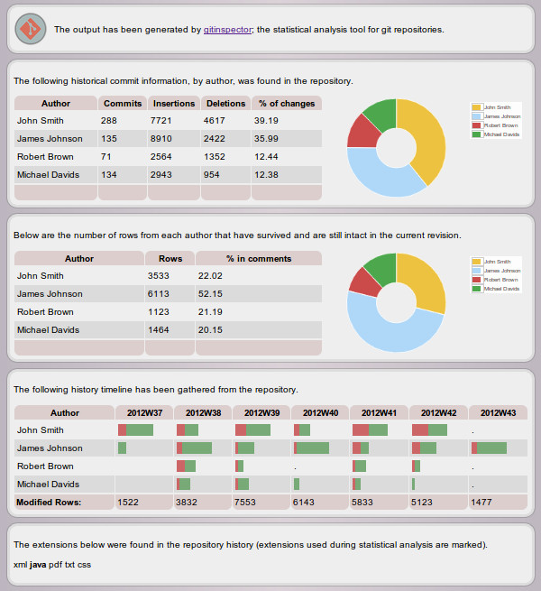

What inputs do you want us to consider?

* Google Docs? Google Sheets?

Usability

* Who is going to be using this computer? Savvy individuals or just duds?

Vision statement

* For client who need to track what type of work is being done on...

Scrum Master

Project Owner

**Vision Statement**

For our client Najam Nazar, who needs a software package that keeps track of who has completed and how much work has been done on a group’s Google Drive folder. The product fulfills a need for such a system that is yet to be currently implemented for the Google Drive system. The software will be largely based upon the existing GitInspector software that has been developed for Git repository systems.Our Product will be created as a web-application that can only be accessed by members with appropriate access.